UNIVERSITY OF BUEA

FACULTY OF ENGINEERING

AND TECHNOLOGY

(FET)

REPUBLIC OF CAMEROON

PEACE-WORK-FATHERLAND



COURSE TITLE: **MOBILE COMMUNICATIONS AND PROTOCOLS**

COURSE CODE:**CEF 356**

COURSE INSTRUCTOR: **Dr NKEMENI VALERY**

## 

# **PROJECT TITLE: RADIO NETWORK PLANNING OF A 4G LTE NETWORK IN THE CITY OF BUEA**

**PROJECT PRESENTED BY**

|  |  |
| --- | --- |
| **NAMES** | **MATRICULATION NUMBER** |
| ABANDA SERGIO ABANDA | FE22A131 |
| ABILATEZIE VIN-WILSON ANU | FE22A132 |
| AGBOR EMMANUEL NCHENGE | FE22A138 |
| NGANYU BRANDON YUNIWO | FE22A258 |
| NGUIMENANG ZEUFACK KEREINE | FE22A266 |
| NSONDO MIRELLE NYISEKINYI | FE22A283 |
| TATA THECLAIRE G | FE22A310 |
| UNJI STEPHEN UKU | FE22A323 |

Table Of Contents

1. Introduction: 3

1.1 AIM: 3

1.2 Analyses 3

2. Calculations 4

2.1. Evaluating the capacity of the network 6

3. Justification for Values: 7

4. Hardware and software requirements 8

4.1. Personal computer 8

4.2. Atoll 8

4.3. Google Earth 8

5. Procedure 8

6. Observations 14

7. Conclusion 14

# **Introduction:**

This report provides a detailed analysis and planning for the deployment of a 4G LTE network in the city of Buea, Cameroon, utilizing the Orthogonal Frequency-Division Multiple Access (OFDMA) with Frequency Division Duplexing (FDD) technique.

# 1.1 AIM:

The aim of our project is to analyze the data collected to build a 4G LTE network using OFDMA/FDD to ensure adequate coverage and obtain an efficient network capacity for the growing population and data usage demands in the city of Buea.

# 1.2 Analyses

OFDMA/FDD Technique: OFDMA is achieved by assigning subsets of subcarriers to individual users. This allows simultaneous low data rate transmission from several users.

The FDD aspect of our chosen technique means that uplink and downlink transmissions occur on separate frequency bands. This allows for simultaneous transmission and reception, which can improve overall system capacity and reduce latency.

**Why we chose OFDMA/FDD:**

1. Spectral Efficiency: OFDMA allows for efficient use of available spectrum by dividing it into narrow, orthogonal subcarriers.
2. Flexibility: It provides flexibility in resource allocation, allowing the network to adapt to varying user demands and channel conditions.
3. Robustness: OFDMA is robust against multipath fading and inter-symbol interference.
4. Scalability: The technique easily scales to different bandwidth allocations.
5. Reduced Interference: FDD helps reduce interference between uplink and downlink transmissions.
6. Lower Latency: FDD allows for simultaneous transmission and reception, potentially reducing overall system latency.

To achieve our aim, we made some analyses taking into consideration many factors in order to obtain an adequate result. These analyses are explained below:

# Calculations

**- Area and Population of the city of Buea:**

The total area of Buea is **86 square kilometers (km²) from google earth analysis,** with a population of approximately **400,000 people**. These factors play a crucial role in determining the number of base stations and cells required to provide sufficient coverage and capacity.

**- Cell Radius and cell Area:**

The chosen cell radius for our LTE network in Buea is **2 kilometers (km).** This value is selected based on several factors, including the terrain characteristics, population density, and desired coverage quality. A smaller cell radius would result in a higher number of cells, potentially improving coverage and capacity but increasing the infrastructure and operational costs.

To calculate the cell area, we use the formula for the area of a regular hexagon:

Cell Area = (3 × √3 × (Cell Radius)²) / 2

Cell Area = (3 × √3 × (2 km)²) / 2

Cell Area = 10.39 km²

**- Number of Cells:**

The number of cells required to cover the entire area can be calculated by dividing the total area by the cell area:

Number of Cells = Total Area / Cell Area

Number of Cells = 86 km² / 10.39 km²

Number of Cells ≈ 8.28 (rounded up to 9 cells)

Therefore, approximately 9 cells are required to provide coverage for the entire area of Buea.

**- Number of Base Stations:**

Number of Base Stations = Number of Cells

Therefore, 9 base stations with 60-degree sectoring will be required to provide coverage for the entire area of Buea.

**- Number of Transmitters:**

Since the network planning considers 60-degree sectoring, each base station will require three transmitters, one for each sector. Therefore, the total number of transmitters required for the LTE network in Buea is:

Number of Transmitters = Number of Base Stations × Number of Sectors per Base Station

Number of Transmitters = 9 × 6

Number of Transmitters = 54

**- Number of Channels, Clusters and Cells per Cluster:**

**For 4G LTE, Bandwidth**= 10MHz

Channel Bandwidth=25kHz

**Number of channels**= 10MHZ/2*25KHZ =200channels

Channels per cell =Number of channels/Number of cells

=200/9= 22R2

**7 cells will have 22 channels and 2 cells will have 23 channels**

Number of cells per cluster= N=3

Total number of clusters=number of cells/cell per cluster =9/3=3

Path loss exponent n=4

SIR=18db

SIR = (√3N)^n/i0

We use 60-degree sectoring

**Calculation**

|  |  |  |  |  |
| --- | --- | --- | --- | --- |
| **Cell Type** | **Cell per cluster(N)** | **Sector per cell** | **Sector per cluster** | **Capacity** |
| **Omni(360-degree)** | **7** | **1** | **7** | **49** |
| **120-degree** | **4** | **3** | **12** | **48** |
| **60-degree** | **3** | **6** | **18** | **54** |

For Omni, SIR = 18db, SIR =10^(18/10) =**63.1**

SIR=(√3N)^n/i0 n=4

SIR=(√3N)^4/i0 => N=√((i0*SIR)/9)

i0=6, N=√((6*63.1)/9)= **6.48 ≈7**

For 120-degree, io=2, N=√((2*63.1)/9) **= 3.74 ≈4**

For 60-degree, io=1, N=√((1*63.1)/9) = **2.64 ≈3**

From the analysis which we made above, we chose 60-degree sectoring because it has the smallest number of cells per cluster and with a greater capacity (Capacity of 54)

**Number of Clusters = Number of Cells / Number of Cells per Cluster**

Number of Clusters = 9 / 3

**Number of Clusters ≈ 3**

# **Evaluating the capacity of the network(Assumption)**

N=3

Frequency allocated=54

Percentage using network= 95%

Population using network= 95% × total population of Buea

= 95% × 400,000 = 380,000 inhabitance

GOS= 2% we use this because the number of persons that will experience block call will be very limited about 2 in a hundred

Traffic per cell=number of carriers/ number of cells per cluster

Number of carriers per cell=54/3=18 carriers

Number of timeslots= 8×18=144

**Traffic channels =144-18=126 channels**

**Control channels = 18 channels**

C=126

GOS=2%=0.02

**Acell = 113.278Erl**

Au=2.5mEr**l**

Population using the network=380,000 users

Total Traffic, A=380,000×2.5×10^-3

**A= 950Erl**

**Number of base stations=number of cells**

🡪 number of cells=total traffic/traffic per cell

=950/113.278

**=8.386 cells ≈ 9 cells**

🡪 **number of base stations = 9**

**- Base Station Height:**

The chosen height for the base stations in Buea is 30 meters. This height is selected based on factors such as the terrain characteristics, population density, and desired coverage quality. Taller base stations can provide better coverage but may also reduce the risk of interference, enhance capacity in urban areas, use of fewer base stations but will require more expensive infrastructure.

# **Justification for Values:**

• **60 Degree Sectoring**: This is a common sectoring approach for LTE networks, providing good coverage with optimal frequency re-use.

• **Cell Radius:** A radius of 2km is chosen based on the terrain and population density of Buea. It ensures a good balance between coverage and capacity.

• **Cluster Size:** A cluster size of 3 balances frequency re-use and cost efficiency, providing a good compromise for this project.

• **Height of Base Stations:** A height of 30 meters provides sufficient coverage while keeping costs manageable.

• **OFDMA/FDD:** This technique provides efficient bandwidth sharing and management among multiple users, improving overall network performance and capacity. It also allows for simultaneous uplink and downlink transmissions, enhancing system efficiency

# Hardware and software requirements

# Personal computer

A capable personal computer served as the primary workstation, running the specialized software required for network planning and design.

# Atoll

Atoll is a comprehensive radio planning and optimization platform, enabled modeling, simulations, and analysis for optimizing network coverage and capacity. Its integration with Google Earth provided realistic terrain data.

# Google Earth

Google Earth furnished geographical data and terrain information, which was seamlessly integrated into Atoll. This integration facilitated accurate consideration of environmental factors impacting signal propagation.

# Procedure

Before physically deploying base transceiver stations (BTS) in the field, their positions must be carefully planned. This planning is facilitated through the use of Geospatial Information Systems (GIS) such as Google Earth. The process begins by launching Google Earth on a computer with an active internet connection to ensure an up-to-date representation of the terrain is available.

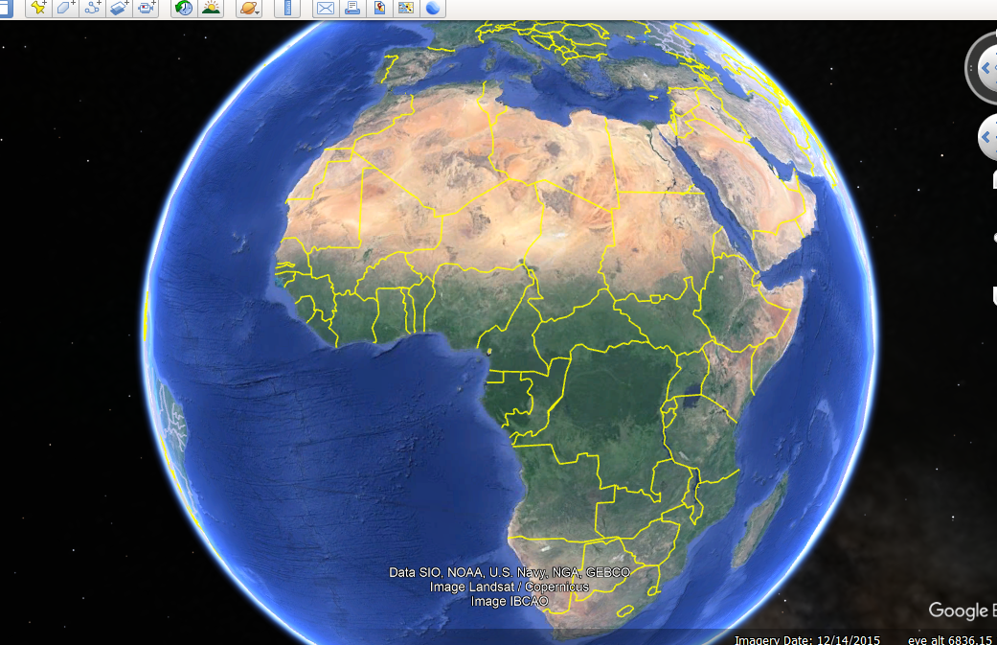

Once Google Earth is open, the desired town or area is located by entering its name in the search panel located in the top-left corner of the window.

**The area under consideration**

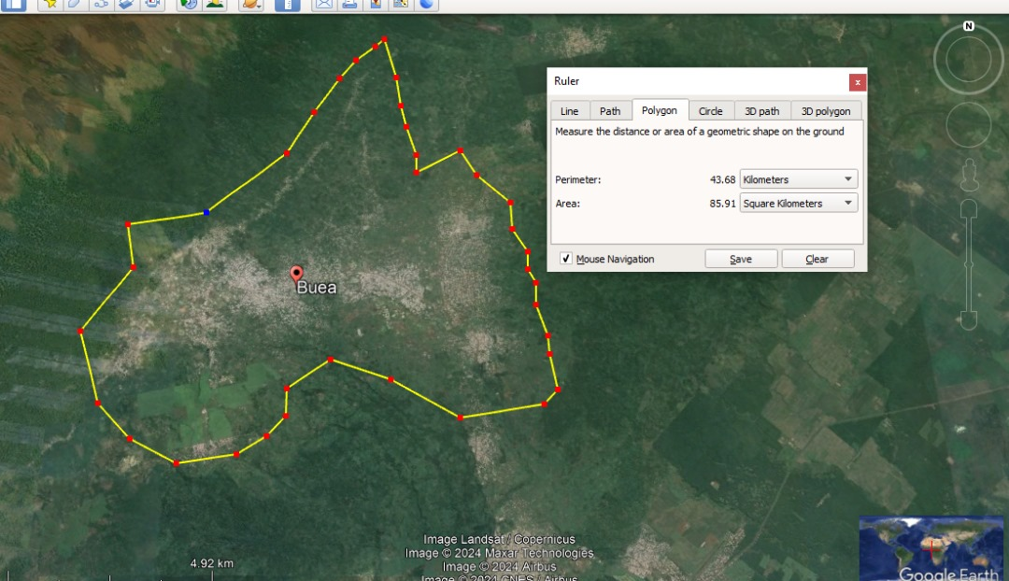

Potential site locations are then marked using place markers, and the corresponding coordinates are recorded in an Excel spreadsheet.

After all desired locations have been mapped out satisfactorily, the resulting layout will resemble the following:

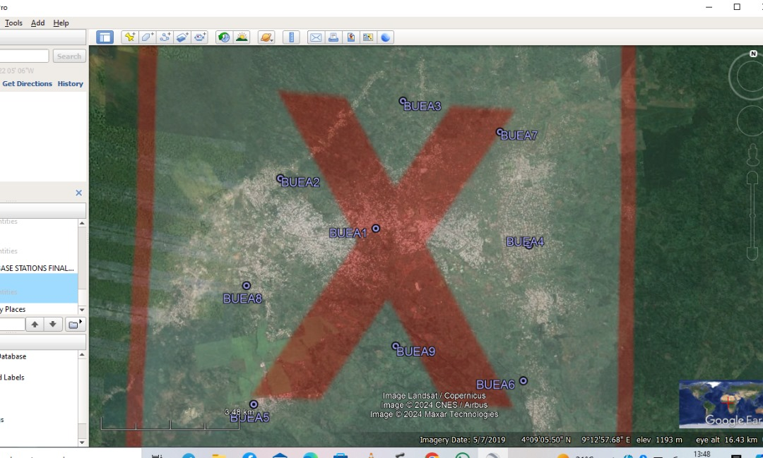

At this point, the site plan is ready for export to radio network planning software such as Atoll. After properly launching Atoll and configuring the appropriate time zones and coordinate systems, the coordinates from the Excel spreadsheet are imported to establish the site locations within the software.

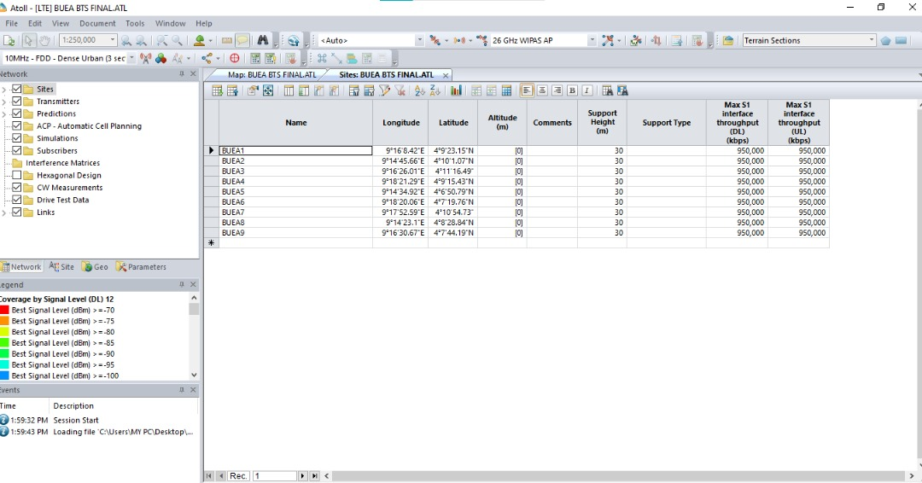

For each site representing a BTS location, six(6) antennas or transmitters are added to implement sectorization, which enhances coverage and signal quality.

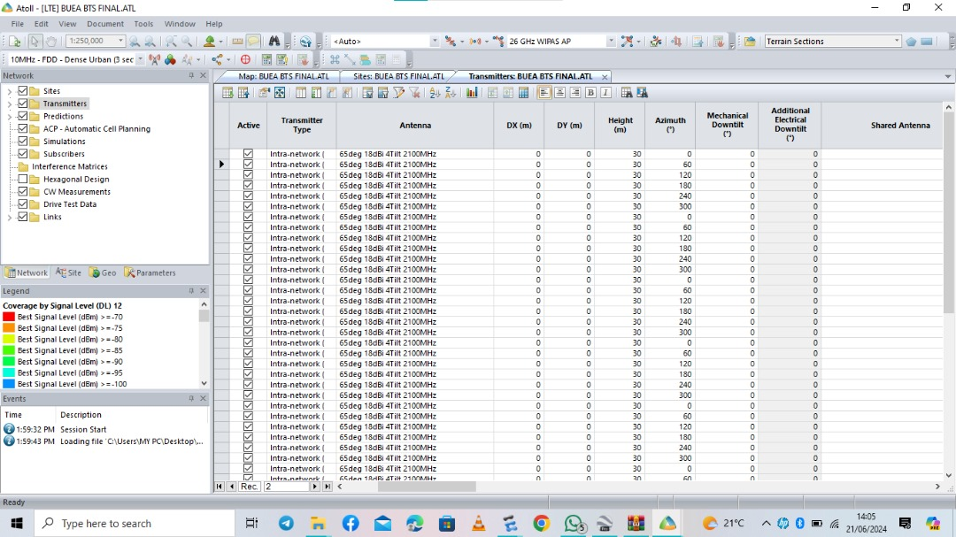

The mechanical azimuth of each transmitter is then manually set to 0°, 60°, 120, 180, 240° and 300 respectively.

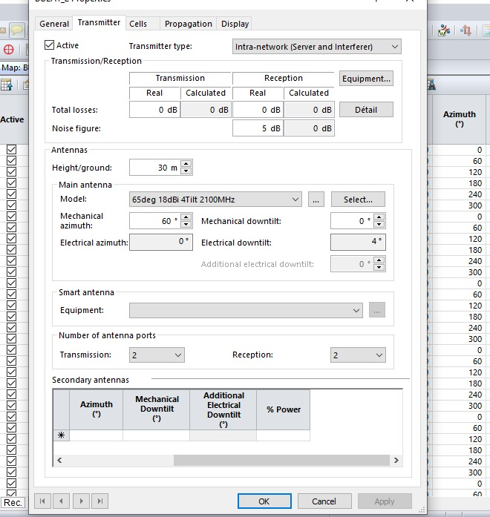

With the site configuration complete, the next step is to calculate the predicted signal coverage levels by setting the prediction mode to "Coverage by Signal Levels (DL)."

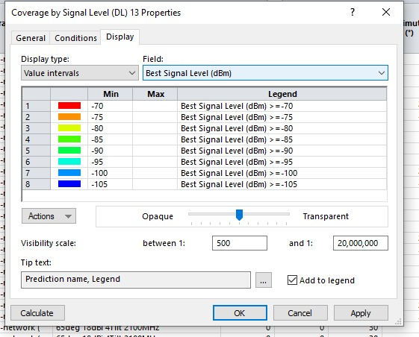

Once the coverage predictions are generated, they can be exported back to the preferred GIS software (Google Earth in this case), resulting in a visual representation similar to the following:

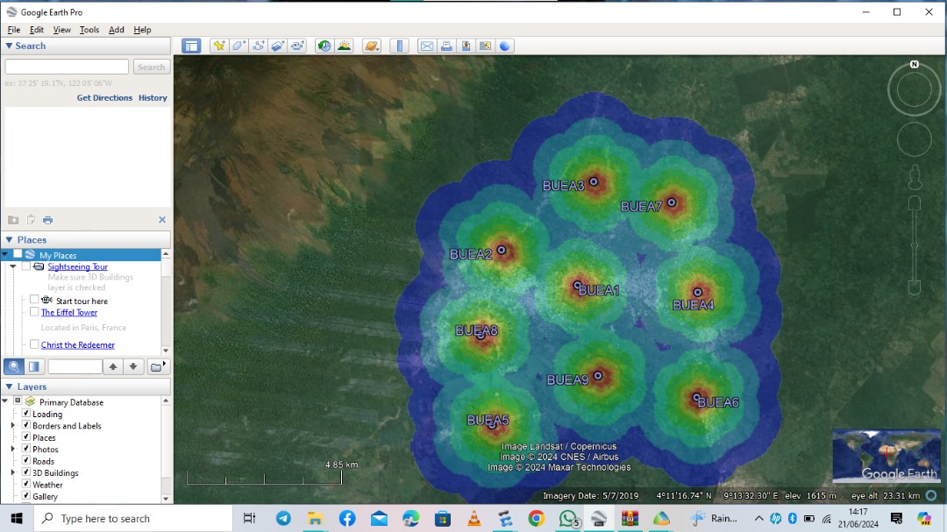

The colors in this representation correspond to the signal level intensity relative to each BTS, with red indicating areas of stronger signal strength and blue denoting weaker signal levels. A legend mapping the signal levels (in decibels) to the different colors is provided:

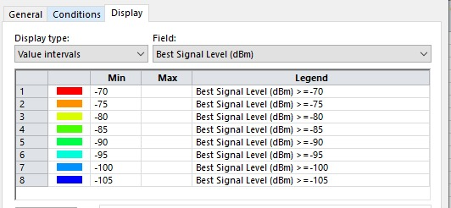

# **Observations**

From the coverage prediction, it becomes evident that achieving optimal network coverage across all areas necessitates the deployment of additional base transceiver stations. The introduction of more BTS will not only enhance the overall coverage but also accommodate a larger subscriber base. As the town continues to grow and expand into currently uninhabited zones, further network planning will be required to maintain adequate service provision.

# **Conclusion**

Based on the given information and calculations, utilizing the OFDMA/FDD technique, the 4G LTE network planning for Buea involves the following key elements:

* Deployment of 9 base stations with 60-degree sectoring
* A total of 9 cells covering the entire area
* Division of the network into 3 clusters, with 3 cells per cluster
* Installation of 54 transmitters in total

This network design aims to provide adequate coverage and capacity for the population of 400,000 people across the 86km² area of Buea. The plan takes into account crucial factors such as:

* A cell radius of 2 km
* Efficient frequency reuse with a cluster size of 3
* Base station height of 30 meters

The proposed configuration is expected to deliver a high-performance 4G LTE network capable of meeting the growing data demands of Buea's population. This design provides a solid foundation for the current needs of the city while also allowing for potential future network expansions or upgrades as demand increases.